eWorkbook 3 by Angela Boult

**Step 1 – Load and Connect to SQL**

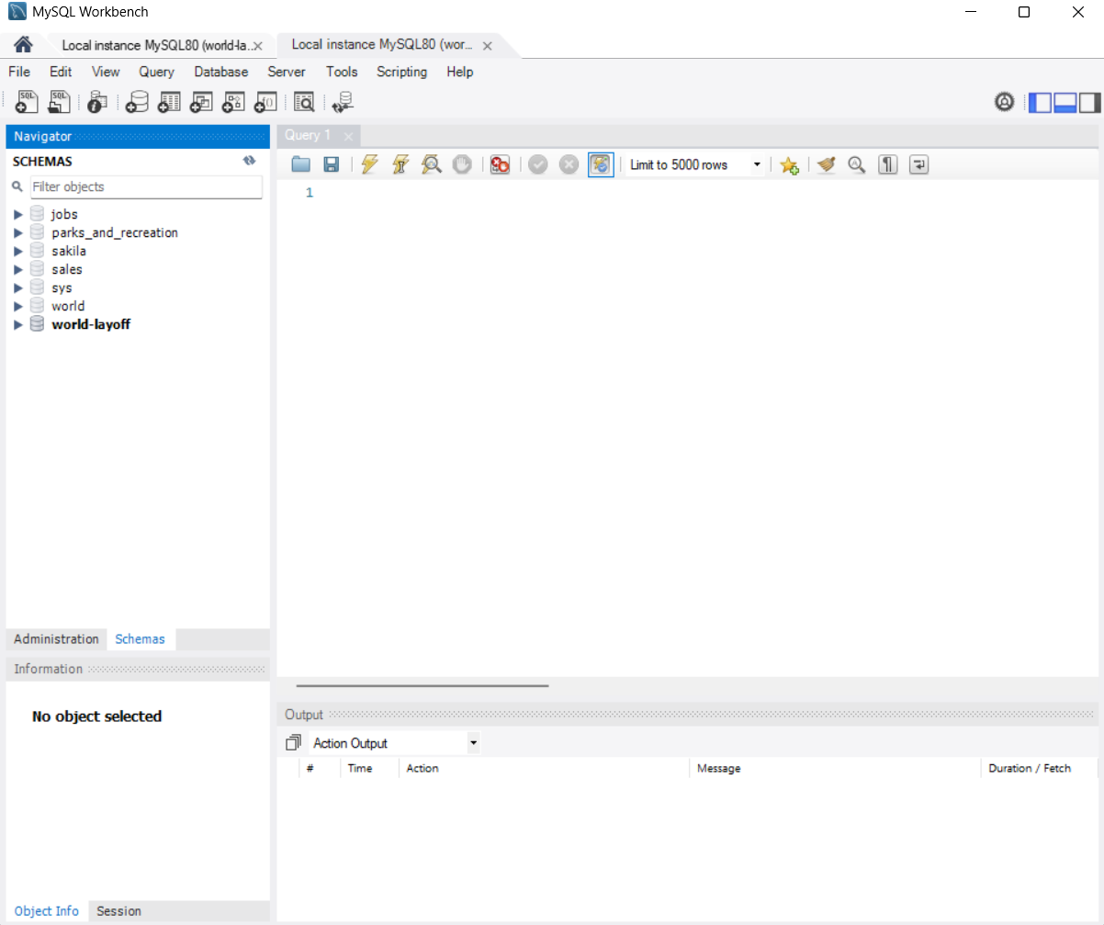

**Step 2 – ERD Alignment and Model Integrity**

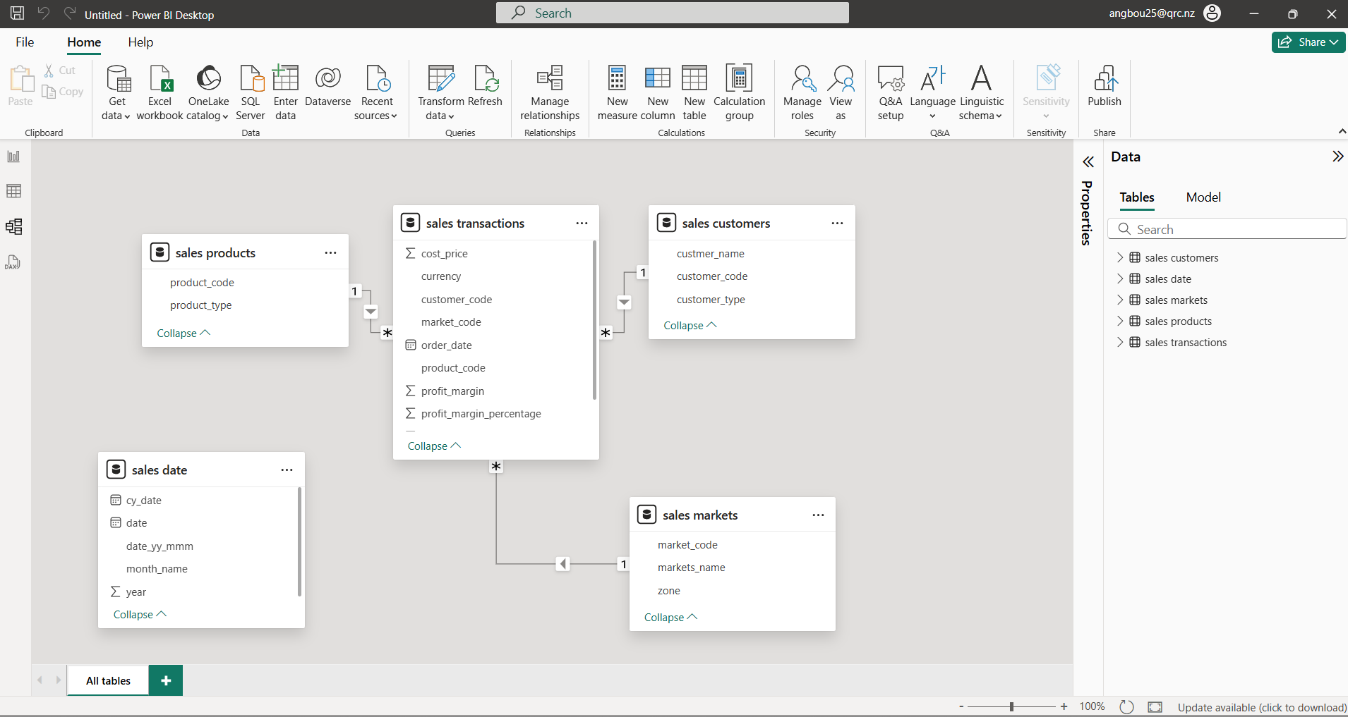

**Step 3 – Data Cleaning**

**Issue 1 – Incorrect currency – change USD to INR**

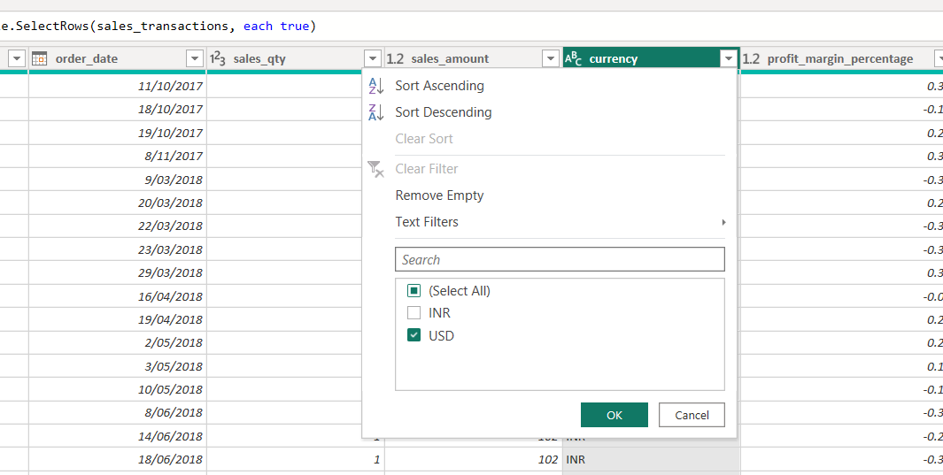

**Issue 2 – Marking Potential Errors**

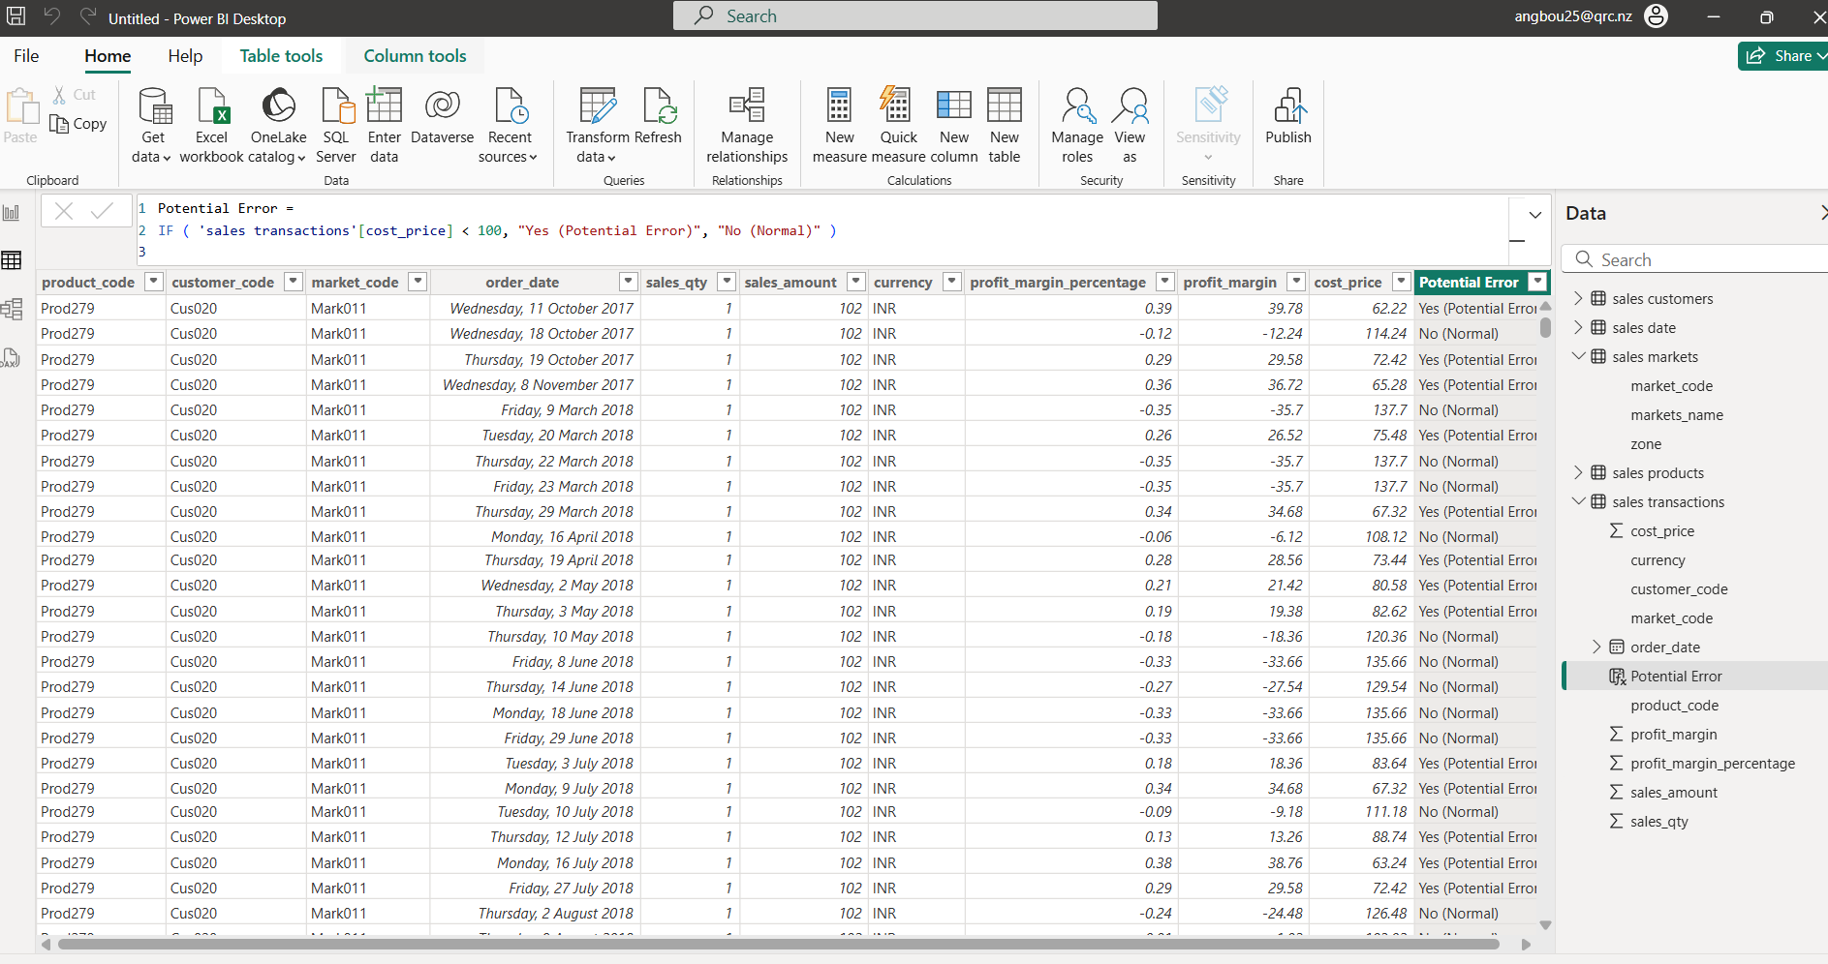

**Step 4 – Build DAX Measures**

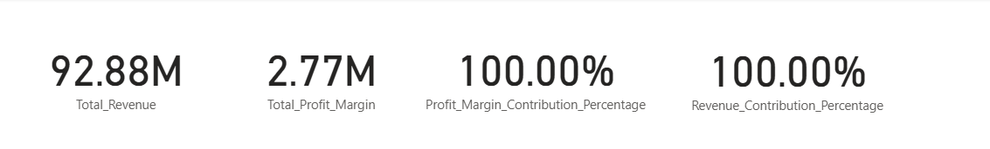

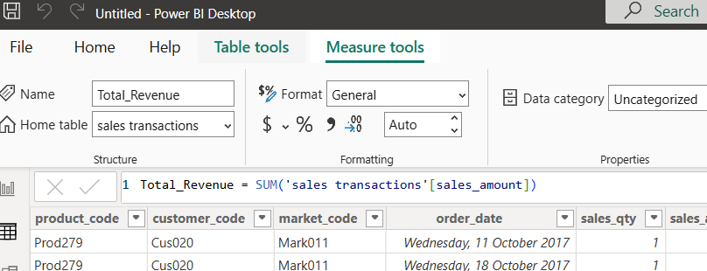

**Step 4 – Vision Creation**

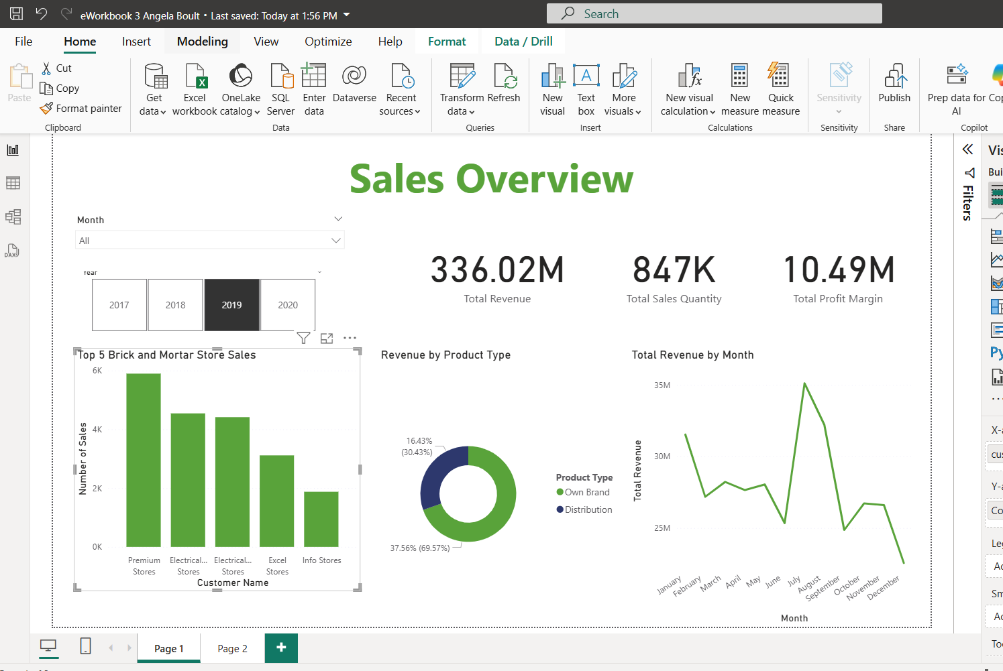

**Step 5 - Report**

Two Key Insights from the Visuals

Insight 1: Over the years, there has been very little change in the top performing brick and mortar stores. Premium stores had reduced sales beginning of 2020 which put it in 4th place from its usual top spot.

Insight 2: They have quite a lot of fluctuation in peak sales throughout the years. Ie Some years have peaks in July/August and others in January. Overall the September / October period did very poorly and the January period has done well.

Quick Win Business Recommendation

Immediately consider closing sales with negative profit margins.

Long Term Business Recommendation

Review sales that have marginal profit margins and consider what could be done to increase the profits from these sales.

Personal Reflection

* 1. What was your biggest challenge?
  2. Not having any knowledge of the sales field, it was a challenge to fully understand what the data was trying to say, and to ensure that the I was getting the result I was expecting, because I don’t have the deeper understanding of the data to notice if something isn’t quite right with the numbers being displayed.
  3. How did building your data model or working with DAX change your thinking?
  4. Working with DAX allowed me to use the data in ways that would be more challenging than in other programmes. It is adding in the kinds of information you can gather from python or excel without having to use those programmes as well, which shows that Power BI can be versatile.
  5. Which visual or insight are you most proud of?
  6. The column chart on page 1, was the first time I really used filters and figured out all of my selections for the axis etc on my own.